Project Report

Hostel Management

SUBMITTED By,

Krupal Patel(18171341093),Meet patel(18171341096)

Patel Parth(18171341100),Pratham patel(18171341102)

Neel Patel(18171341097)



SUBMITTEDTO,

Department of Computer Engineering

B.S. Patel College of Engineering

Ganpat University,Kherva-384012

|  |  |
| --- | --- |
| SR No. | **Table of Content** |
| 1. | Introduction |
| 2. | System requirement Specification List of Table |
| 3. | Problem Solution outline |
| 4. | List of Table |
| 5. | List of Figure |
| 6. | Conclusion |
| 7. | References |

**Index**

|  |  |
| --- | --- |
| 1. | Introduction |
| 1.1 | Abstract |
| 1.2 | Objective and scope |
| 1.3 | Existing System |
| 1.4 | Technology Overview |
| 1.4.1 | Front end technology |
| 1.4.2 | Back end technology |

|  |  |
| --- | --- |
| 2. | System requirement Specification and Tools |
| 2.1 | Requirement Gathering and Analysis |
| 2.2 | Software requirement Specification |
| 2.3 | Hardware requirement Specification |
| 2.4 | Feasibility |

|  |  |
| --- | --- |
| 4. | List of Table |
| 4.1 | Student |
| 4.2 | Registration |

|  |  |
| --- | --- |
| 5. | List of figure |
| 5.1 | Login Diagram |
| 5.2 | DFD Diagram |
| 5.3 | Registration |
| 5.4 | Technology Overview |

1. **Introduction**

This system is designed of the hostel management which helps them to save the records of the students about their rooms and other things. It helps them from the manual work from which it is very difficult to find the record of the students and the mess bills of the students, and the information of about the those ones who had left the hostel years before. This system gives an idea about how a student and fee details, room allocation, mess expenditure are maintained in a better way. The hostel management system will also contain special features like how many students are in a room, student’s id and free rooms or space available. The administration has a unique identity for each member as well as students details.

* 1. **Abstract**
* As the name specifies “HOSTEL MANAGEMENT SYSTEM” is a software developed for managing various activities in the hostel. For the past few year, the number of educational institutions is increasing rapidly.
* Thereby the number of hostels are also increasing for the accommodation of the students studying in this institution. And hence there is a lot of strain on the person who are running the hostel and software’s are not usually used in this context.
* This particular project deals with the problems on managing a hostel and avoids the problems which occur when carried manually.

**1.2 Objectives**

• To make it easier for data collection, storage and referencing reliable.

• To maintain the students as hostellers and waiting list students separately.

• To process allotment list.

**1.3 Existing System**

The existing system is manual based and need lot of efforts and consume enough time. In the existing system we can apply for the hostels online but the allotment processes are done manually. It may lead to corruptions in the allocation process as well as hostel fee calculation. The existing system does not deals with mess calculation and complaint registration

**1.4 Technology Overview**

* **Software languages**
  + 1. Front end : PHP
    2. Back end : MY SQL server

**2.** **System requirement Specification and Tools**

**2.1** **Requirement Gathering and Analysis**

Functions and features delivered to the end users. The end users of the proposed system are:

**USER MODULE**

This helps the administrator and user to login to homepage only if password and username matches.

**CHANGE PASSWORD MODULE**

Allows the user to change the password.

**STUDENT MODULE**

This module is used to store student details i.e. information like profile details, contact information, educational details etc. Users can search according different criteria such as name, course, room number etc.

**ROOM ALLOTMENT MODULE**

This deals with allocation of room to students according to education details, section or course. Rooms will be allocated to students and an ID will be generated for it. It will display details studen2ts staying in the room or rooms. When a student leaves the room after the semester, the left date will be also saved.

**SETTINGS MODULE**

In this module, only the administrator can access. Administrator has a unique account with much special access and permissions over normal users. Module allows add, edit, delete and employee records, building block information, room details, course details etc.

**2.2 Software Requirment :**

XAMPP Software (This install Apache server and my sql)

Programming server: Apache server

Database server: My sql

**2.3 Hardware Requirment :**

Processor speed: 1.4 GHz Onwards

System memory: 128 MB minimum (256 MB recommended)

Cache size: 512 KB RAM: 512 MB (Minimum)

Hard disk: 80 GB

**2.3 Feasibility:**

Technical Feasibility

Economic Feasibility

Operational Feasibility

**2.** **Tools**

1. **HTML :** HTML (Hyper Text Markup Language) is the most basic building block of the Web. It defines the meaning and structure of web content. Other technologies besides HTML are generally used to describe a web page's appearance/presentation CSS. "Hypertext " refers to links that connect web pages to one another, either within a single website or between websites.  Links are a fundamental aspect of the Web. By uploading content to the Internet and linking it to pages created by other people, you become an active participant in the World Wide Web.
2. **PHP :** PHP is an acronym for “ PHP: Hypertext Preprocessor “. PHP is a widely-used, open source scripting language. PHP scripts are executed on the server. PHP is free to download and use.
3. **CSS :** CSS stands for Cascading Style Sheets. CSS describes how HTML elements are to be displayed on screen, paper, or in other media. CSS saves a lot of work. It can control the layout of multiple web pages all at once. External stylesheets are stored in CSS files.
4. **My SQL :** MySQL is a fast, easy-to-use RDBMS being used for many small and big businesses. MySQL is developed, marketed and supported by MySQL AB, which is a Swedish company. MySQL is released under an open-source license. MySQL works very quickly and works well even with large data sets. MySQL is very friendly to PHP, the most appreciated language for web development.
5. **XAMPP :** XAMPP is a free and open-source cross-platform web server solution stack package developed by Apache Friends, consisting mainly of the Apache HTTP Server, Maria DB database, and interpreters for scripts written in the PHP programming languages.

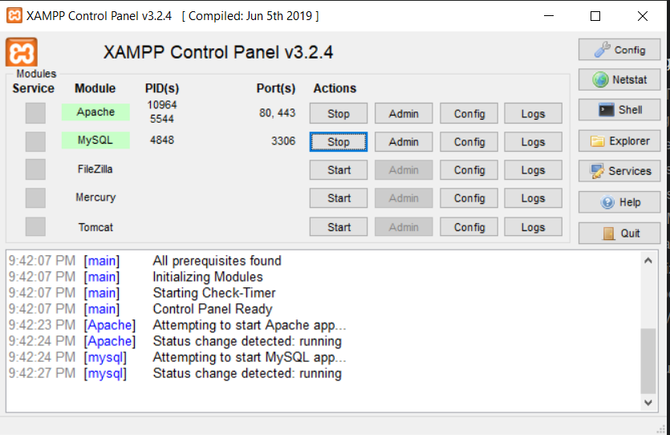

* **User Requirements**

- To gain access to the e-registration system, the user would need:

1. A personal computer

2. A username

3. A genuine password

**3. PROBLEM STATEMENT**

There are a lot of drawbacks in keeping and maintaining a hostel. Especially with a manual system. Since most hostels are being run by only one hostel manager, the number of students in a room are sometimes not known by the officer. He has to go room by room to ensure that a room is occupied or not. Sometimes people may be owing in the hostel and they are saved on papers or huge notebooks, and sometimes receipts. If the books should go missing or stolen, one would never be able to know if a student is owing or not. Room allocation also becomes a problem as the officer might not know which rooms are available or not. And some hostels have a lot of rooms or have mare storeys and it would be very tedious to go through all storeys in search of a free room for an applicant. Also the officer might not know the number of students in a room or know if a room is full or not.

**4. Table**

**Student**

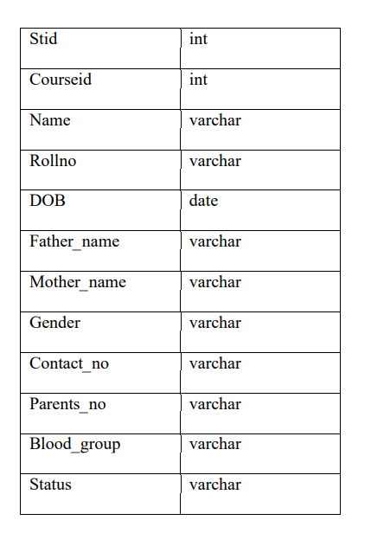

**Registration**

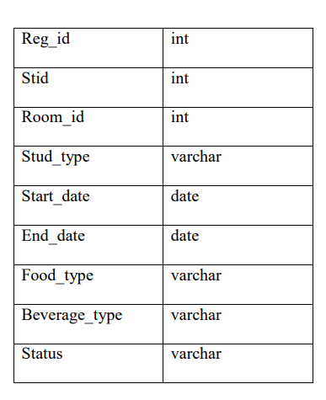

**5.Figure**

**Login module**

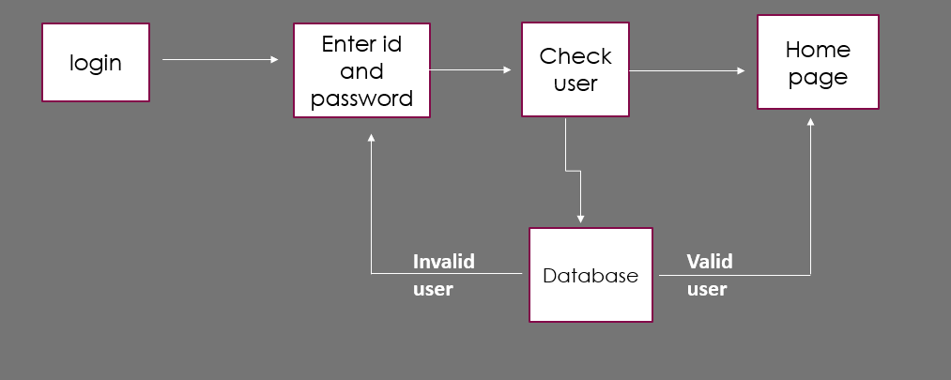

**DFD module level 0**

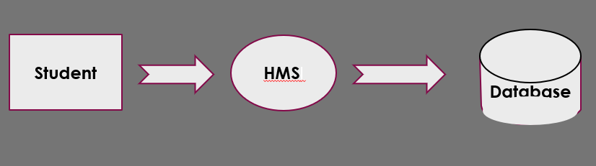

**DFD module level 1**

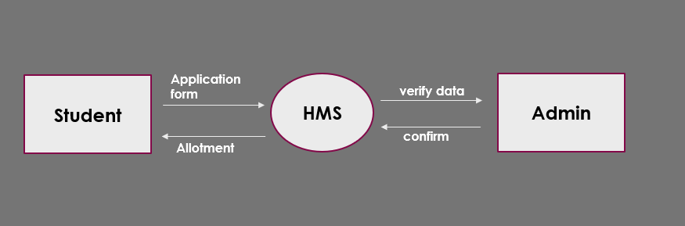

**DFD module level 2**

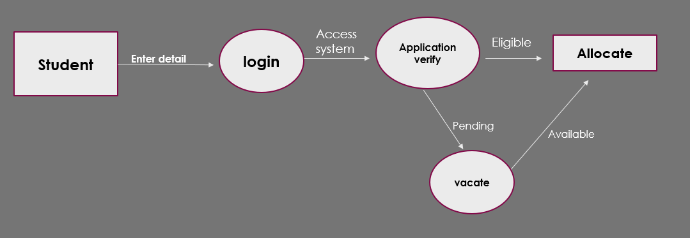

**Registration module**

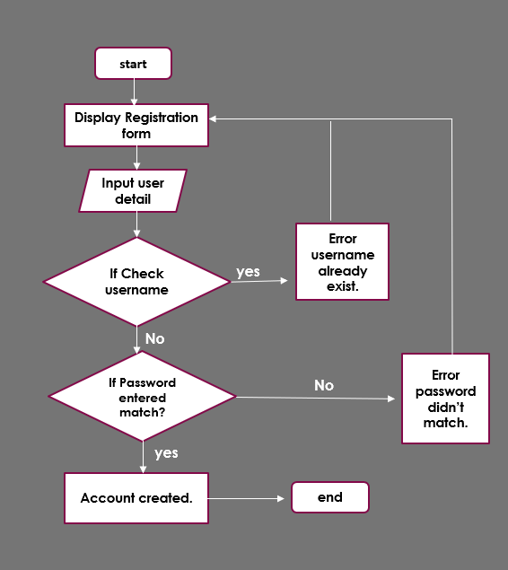

ER Diagram

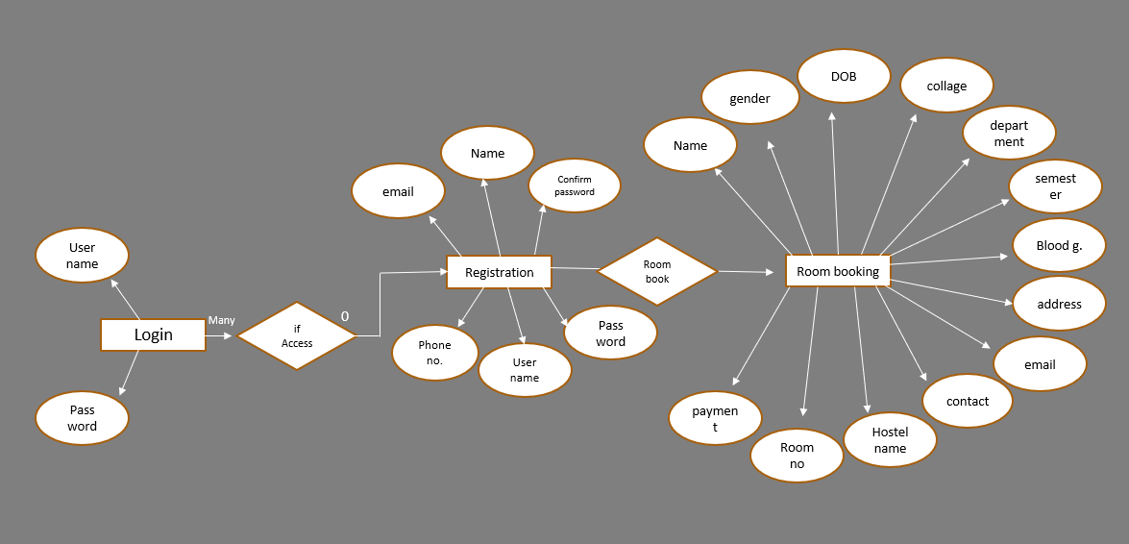

**DESIGN IMPLEMENTATION**

Design implementation refers to there alive running of the designed program. This section consists of the program modules, showing what they represent, and how the system can be deployed.

* **Login page**

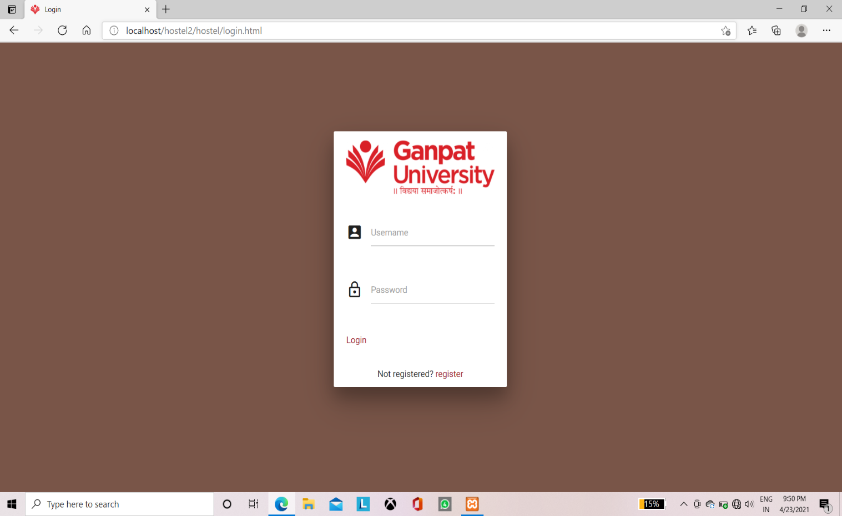

* **Registration page**

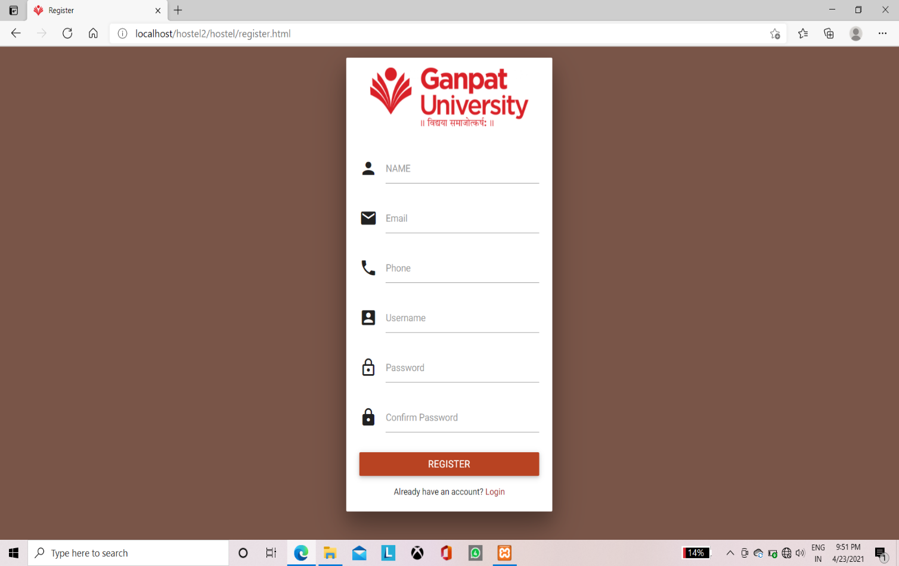

* **Home page**

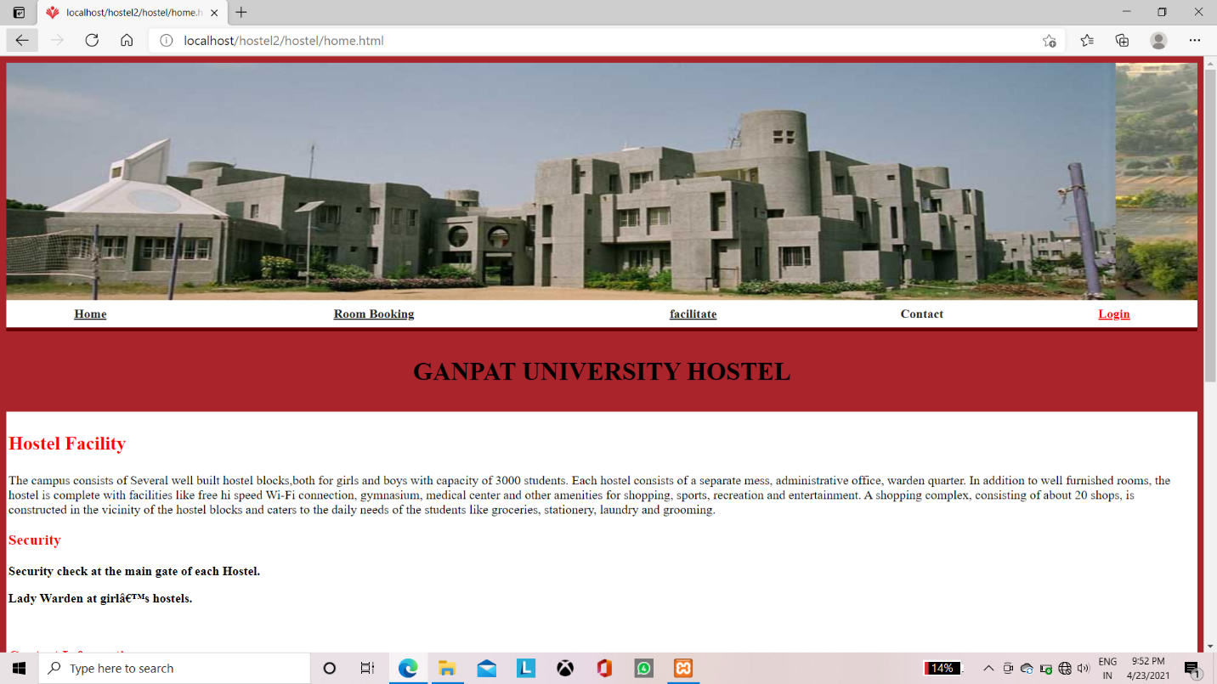

* **Database**

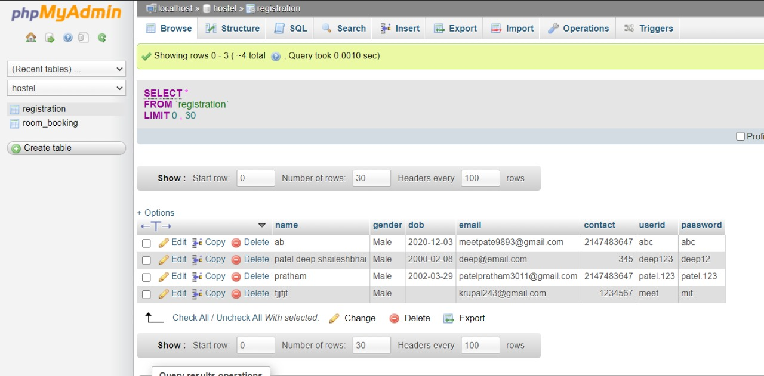

**Conclusion**

* The project Hostel management system is for computerizing the working in a school/ college hostels.
* The website take care for the requirement of registration and is capable to provide easy and effective storage of information related student that come up to the hostels.

**References**

1. HTML Elements

2. CSS Elements

3. PHP Manual

**Thank you**